**PIZZA SALES SQL QUERIES**

1. KPI’s
2. **Total Revenue**



**Output**

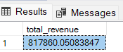

1. **Average order value**

**Output**

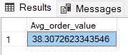

1. **Total pizza sold**



**Output**

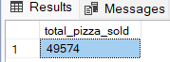

1. **Total Orders**



**Output**

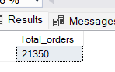

1. **Avg pizzas per order**



**Output**

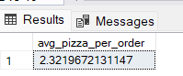

**Hourly trend for total pizza sold**

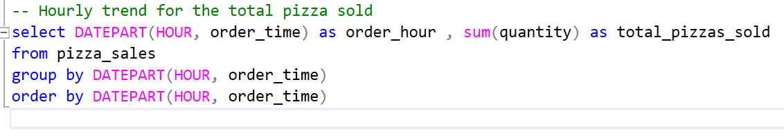

**Output**

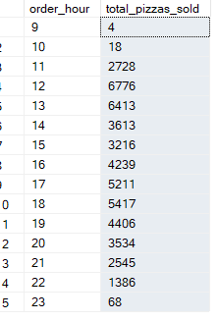

**Weekly trends for total orders**

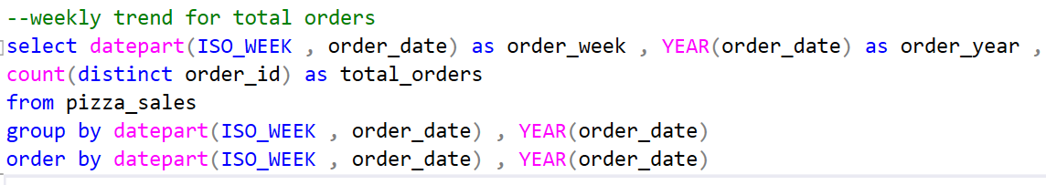

**Output**

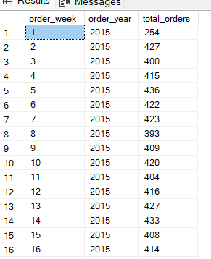

**Revenue per pizza category**

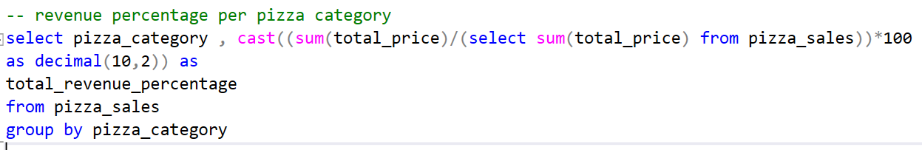

**Output**

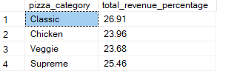

**Percentage revenue per pizza size**

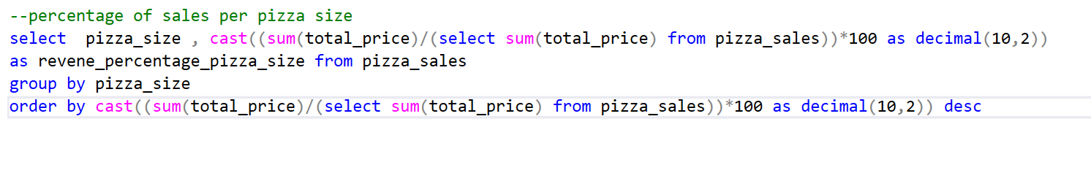

**Output**

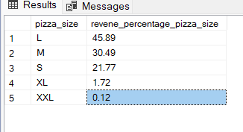

**Top 5 best sellers pizza by revenue**

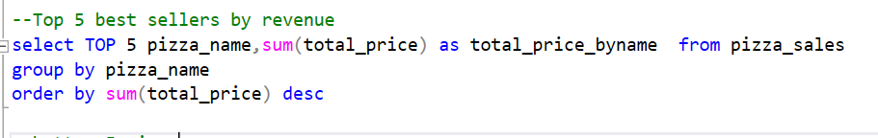

**Output**

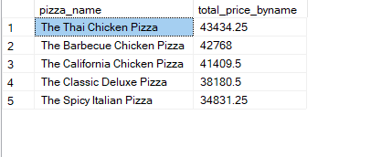

**Bottom 5 pizza by revenue**

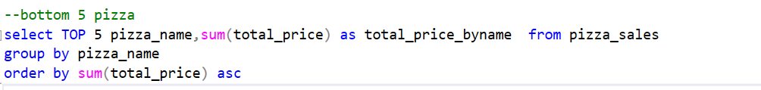

**Output**

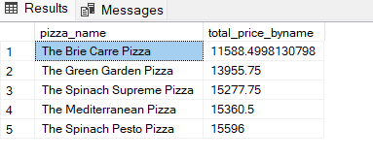

**Top 5 pizza by quantity**

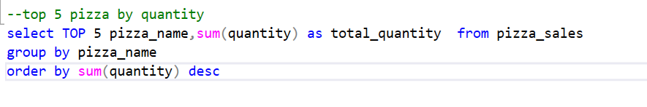

**Output**

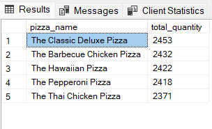

**Bottom 5 pizza by quantity**

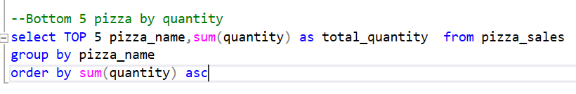

**Output**

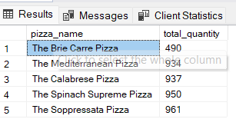

**Top 5 pizza by total orders placed**

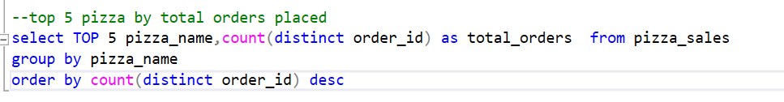

**Output**

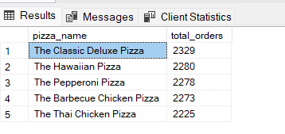

**Bottom 5 pizza by orders placed**

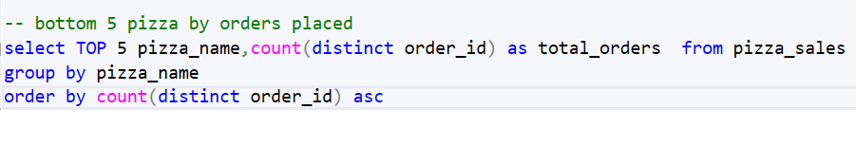

**Output**

**NOTE**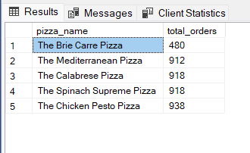

**If you want to apply the pizza_category or pizza_size filters to the above queries you can use WHERE clause.**

**Follow some of below examples**

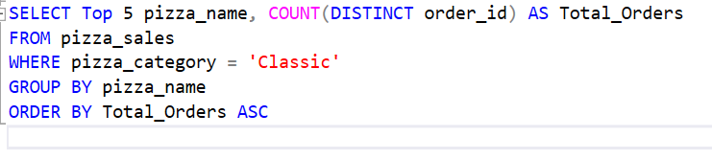

**Output**

